**HTML <iframe> scrolling Attribute**

Last Updated : 23 Jul, 2024

The **HTML <iframe> scrolling Attribute**is used to specify whether the scrollbar will be displayed or not in the <Iframe> Element. Basically, the scrollbar is used when the content is larger than the Iframe Element.

**Note:**This attribute has been DEPRECATED and is no longer recommended.

**Syntax**

<iframe scrolling="auto | yes | no">

**Attribute Values**

| **Attribute Values** | **Description** |
| --- | --- |
| **auto** | It has a default value. The scrollbar appears when needed. |
| **yes** | This value shows the scrollbar in the Iframe Element. |
| **no** | This value does not show the scrollbar in the Iframe Element. |

**Example:** the implementation of  <iframe> scrolling Attribute



1

<!DOCTYPE html>

2

<html lang="en">

3

​

4

<head>

5

<meta charset="UTF-8">

6

<meta name="viewport"

7

content="width=device-width, initial-scale=1.0">

8

<title>Document</title>

9

<style>

10

body {

11

text-align: center;

12

}

13

</style>

14

</head>

15

​

16

<body>

17

<h1 style="color: green;">

18

GeeksForGeeks

19

</h1>

20

<h2>

21

HTML Iframe scrolling Attribute

22

</h2>

23

​

24

<p>Content goes here</p>

25

​

26

<iframe src="https://en.wikipedia.org/wiki/Main_Page"

27

height="300" width="400"

28

marginwidth="50" scrolling="yes">

29

</iframe>

30

​

31

</body>

32

​

33

</html>

**Output:**

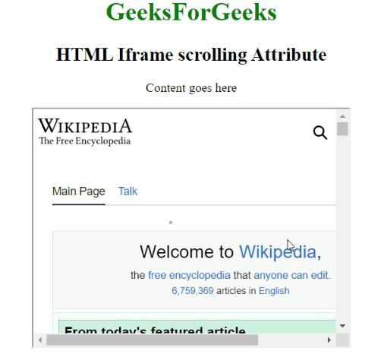

1 / 3

**Example 2:**the implementation of <iframe> scrolling with no scrolling attribute.



1

<!DOCTYPE html>

2

<html lang="en">

3

​

4

<head>

5

<meta charset="UTF-8">

6

<meta name="viewport"

7

content="width=device-width, initial-scale=1.0">

8

<title>Document</title>

9

<style>

10

body {

11

text-align: center;

12

}

13

</style>

14

</head>

15

​

16

<body>

17

<h1 style="color: green;">

18

GeeksForGeeks

19

</h1>

20

<h2>

21

HTML Iframe scrolling Attribute

22

</h2>

23

​

24

<p>Content goes here</p>

25

​

26

<iframe src="https://en.wikipedia.org/wiki/Main_Page"

27

height="300" width="400"

28

marginwidth="50" scrolling="no">

29

</iframe>

30

​

31

</body>

32

​

33

</html>

**Output:**

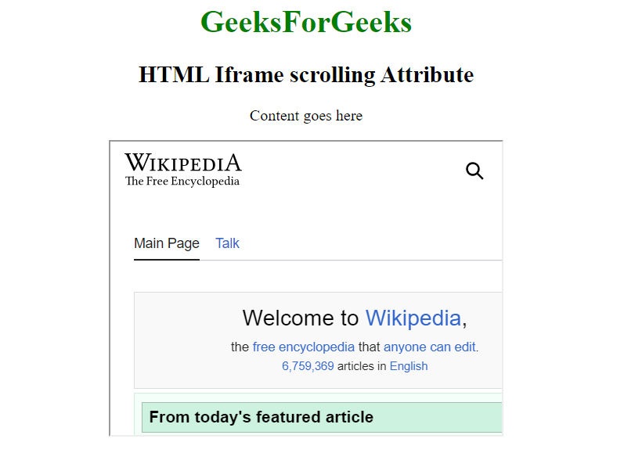

**Supported Browsers:**

* Google Chrome 1
* Microsoft Edge 12
* Firefox 1
* Opera 15
* Safari 4

Comment

More info

[Advertise with us](https://www.geeksforgeeks.org/about/contact-us/?listicles)

[**Next Article**](https://www.geeksforgeeks.org/html-iframe-src-attribute/?ref=next_article)

[HTML | <iframe> src Attribute](https://www.geeksforgeeks.org/html-iframe-src-attribute/?ref=next_article)

**Similar Reads**

**[HTML <iframe> align Attribute](https://www.geeksforgeeks.org/html-iframe-align-attribute/?ref=lbp)**

[The HTML <iframe> align attribute is used to specify the alignment of the inline-frame according to the alternate element. Syntax <iframe align="left|right|middle|top|bottom"> Attribute Values left: It sets the alignment of an iframe to left.right: It sets the alignment of an iframe to r](https://www.geeksforgeeks.org/html-iframe-align-attribute/?ref=lbp)

[1 min read](https://www.geeksforgeeks.org/html-iframe-align-attribute/?ref=lbp)

**[HTML | <Iframe> frameborder Attribute](https://www.geeksforgeeks.org/html-iframe-frameborder-attribute/?ref=lbp)**

[The HTML Iframe frameborder Attribute is used to specify whether or not to display the border around the content of an <Iframe> Element. Syntax: <iframe frameborder="1 | 0"> Attribute Values: 0: It has a Default value. It sets the border on one state. 1: It sets the border on-off state.](https://www.geeksforgeeks.org/html-iframe-frameborder-attribute/?ref=lbp)

[1 min read](https://www.geeksforgeeks.org/html-iframe-frameborder-attribute/?ref=lbp)

**[HTML | <iframe> height Attribute](https://www.geeksforgeeks.org/html-iframe-height-attribute/?ref=lbp)**

[The HTML <iframe> he](https://www.geeksforgeeks.org/html-iframe-height-attribute/?ref=lbp)